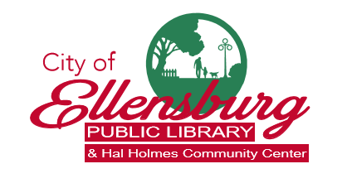

209 North Ruby Street, Ellensburg WA 98926

LIBRARY BOARD MEETING
Council Chamber Conference Room
4:30pm, Tuesday, March 10, 2020

AGENDA
- Call to order; welcome guests
- Approval of the Agenda
- Approval of February 11, 2020 minutes
- Citizen Comment/Suggestions
- Reports
A. Director's report
B. Budget Report
C. Friends’ Report

- Old Business
      - Retreat Recap and Discussion

- New Business
      - Welcome new Board member!
      - Emergency Preparedness Procedure

- Upcoming Programs/Events
March 7/21 FOL Book Barn Sale 1:15pm-4pm
March 11 Women in Science Series: Part 2 Carey Gazis, HH 7pm
March 12 Adult Storytime, 6pm
March 14 St. Patrick’s Day Community Celebration, HH 10am
March 16 Library Book Club: While the City Slept by Eli Sanders, HH 6:30pm
March 18 Women in Science Series: Part 3 Megan Walsh, HH 7pm
March 23-27 Spring Break (schools)
March 24 Virtual Reality program, 5-7pm
March 26 Adult Readers Theatre, 6pm

- Unscheduled Business

Next regular meeting will be April 8, 2020
City Council Chamber

